# Appendix - Statistical Records

In this Appendix we record the results of statistical tests. Shapiro–Wilk test and Levene's test have been performed to assess normality and variance homogeneity, which is the pre-requirement of using T-test. We perform T-test or Wilcoxon test depending on assess results. Results tested by Wilcoxon test are tagged with ‘#’.

***Data Dispersion***

|  |  |
| --- | --- |
|  | ‘10w’-‘40w’ |
| ACC | 0.55 |
| Round | 0.0025 * |

***Delayed Update***

|  |  |  |  |  |  |  |
| --- | --- | --- | --- | --- | --- | --- |
| Proportion | ‘0’-‘<50’ | ‘<50’-‘50’ | ‘50’-‘>50’ | ‘0’-‘50’ | ‘0’-‘>50’ | ANOVA |
| Acc | 0.17 | 0.011 * | 0.16 | 0.017 * | 0.0079 * | 0.63 |
| Round | 0.022# * | 0.45# | 1# | 0.022#* | 0.11# | 0.21 |

|  |  |  |  |  |  |  |
| --- | --- | --- | --- | --- | --- | --- |
| Delay Speed | ‘0’-‘3’ | ‘3’-‘12’ | ‘12’-‘30’ | ‘0’-‘12’ | ‘0’-‘30’ | ANOVA |
| Accuracy | 0.17 | 0.03 * | 0.41 | 0.055 | 0.05 * | 0.96 |
| Round | 0.022# * | 0.45# | 0.67# | 0.022# * | 0.076# | 0.32 |

***Data Dispersion***

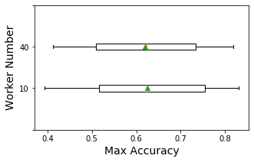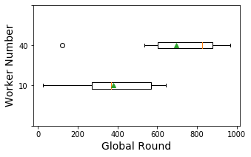

***Delayed Update***

